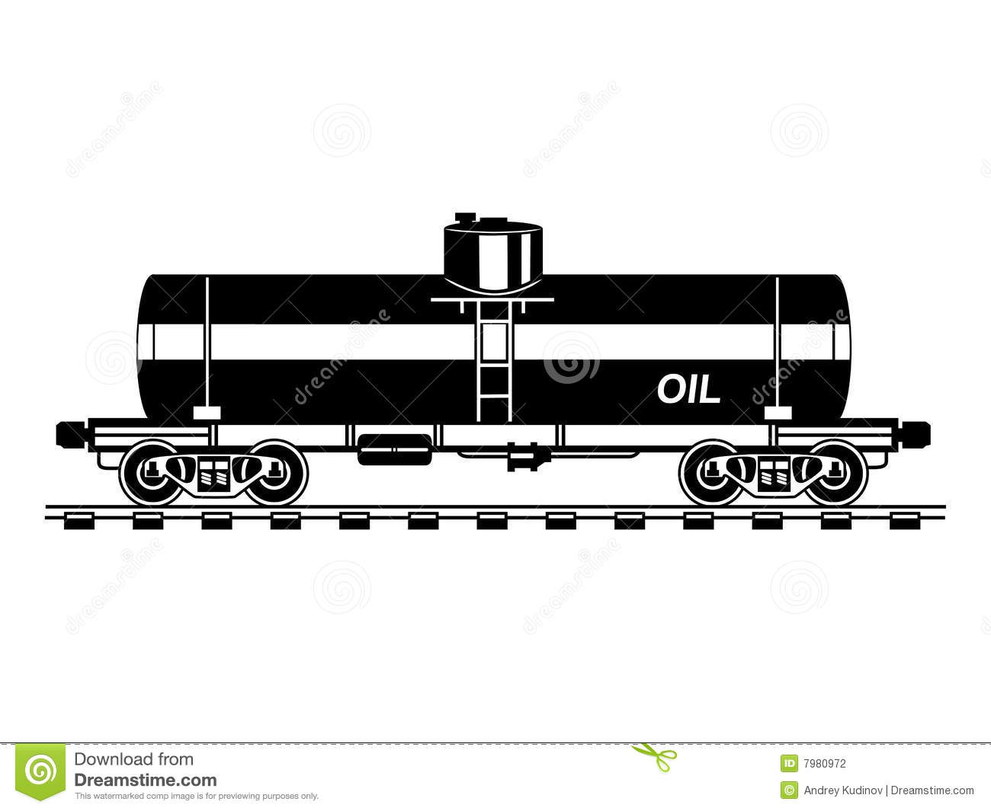
Tell Railroad Executives gathering in Chicago that we say "No" to Bomb Trains!

North American Rail Shippers Association
2015 Annual Meeting
Wednesday May 27, 2015 12:00 - 6:00 PM
The Drake Hotel
140 East Walton Place
(932 North at Michigan Avenue)
Chicago, IL
https://www.facebook.com/events/1583819785229283/
Chicago Greens www.IllinoisGreens.org

