Chicago Greens
http://www.illinoisgreens.org/

For Information: Charles Paidock (312) 842-5036 cpaidock@hotmail.com
Robert Rudner (312) 719-5719 robertrudner@gmail.com
Wes Green (773) 306-5402 wesgreen@ripco.com

Date: May 25, 2016

To: Illinois Legislature

From: Charles Paidock, Secretary cpaidock@hotmail.com
3211 S. Union Ave (312) 842-5036
Chicago, IL 60616-5251 (312) 714-7790 cell

Re: Exelon nuclear bailout bill SB1585 – Floor Amendment 3 “Next Generation Energy Plan”

www.illinoisgreens.org

Thank you for your assistance in this regard concerning these important ecological issues.
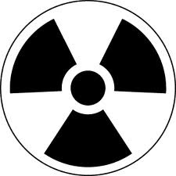
Say NO to Exelon’s corporate welfare bailout!
· No bailouts for Exelon’s aging, money losing reactors
· Fix the Renewable Portfolio Standard, and expand
renewable energy
· Enact a “just transitions” program for reactor
communities and displaced workers;
· Enact strong reactor decommissioning laws

Protect Energy Efficiency Portfolio Standards and LIHEAP Programs:
Please co-sponsor: SB 3383 and HB 5971
SB 3383 and HB 5971 both ask for full funding and protection for the Energy Efficiency Portfolio Standards (EEPS) Fund, and SB 3383 also asks for full funding and protection for the Low Income Heating and Energy Assistance Program (LIHEAP) and the Renewable Energy Resources Fund (RERF).

