Chicago Greens
Monthly Meetings
2nd Sunday of Each Month
2-4:00 PM
Powell’s Bookstore
Halsted and Roosevelt
(800 W, 1200 S)
www.illinoisgreens.org

Program on Sunday, November 8th at 2:00 PM
Elevate Energy
Elevate Energy is a community of thinkers and doers who believe that everyone should have the access to resources that enable more efficient energy use. http://www.elevateenergy.org/

“Elevate Energy is a non-profit committed to smarter energy use for all. They design and implement energy efficiency programs that cut costs, protect the environment, and ensure that benefits reach those who need them most. Field Organizer Elizabeth Corrado will talk about the switch to a smart electrical grid and pricing programs which leverage new smart meters to allow you to pay based off of when you use your electricity. She will also talk about basic home improvements that can cut energy bills and make homes more comfortable year-round. Finally, she will discuss ways you can support policy that promotes energy efficiency, clean jobs, and renewable energy.”

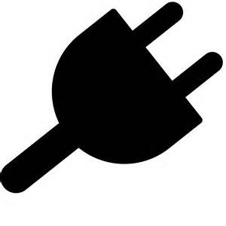

Read Blog by Category
Affordable Housing Energy Efficiency & Sustainability
Building Owners & Managers Home Savings
Community Energy Planning Research & Results
Dynamic Pricing & Smart Grid Tips & Tools

www.illinoisgreens.org

