Chicago Greens
Monthly Meetings
2nd Sunday of Each Month
2-4:00 PM
Powell’s Bookstore
Halsted and Roosevelt
(800 W, 1200 S)
www.illinoisgreens.org

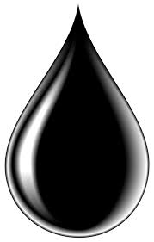
All About OIL
Li-Ping Yuan, Geologist, Dr. Lora Chamberlain of Frack Free Illinois + ChiOilbyRail, Mike Lee on transportation, Charles Paidock on tank car trains, + others

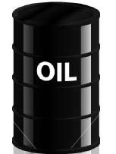

Saturday, August 29th at 6:00 PM
at the
College of Complexes - weekly free speech forum
www.collegeofcomplexes.org
Hilltop Restaurant, 2800 W. Foster (at California)
www.illinoisgreens.org

