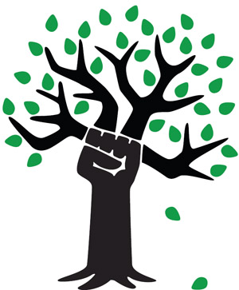
Chicago Greens
Monthly Meetings
2nd Sunday of Each Month
2-4:00 PM
Powell’s Bookstore
Halsted and Roosevelt
(800 W, 1200 S)
www.illinoisgreens.org

Special Earth Day Speakers
Debate on the question of

What Kind of Energy
Future Do We Want?

John Kutsch, Thorium Energy Alliance (TEA) vs.
Dennis Nelson, Nuclear Energy Information Service (NEIS)

Saturday, April 18th at 6:00 PM
at the
College of Complexes
www.collegeofcomplexes.org
weekly free speech forum
Hilltop Restaurant, 2800 W. Foster (at California)

www.illinoisgreens.org

