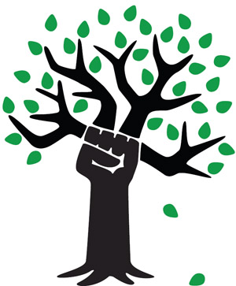
Chicago Greens
www.illinoisgreens.org

Special Upcoming Ecological Speakers
Each Program on Saturday at 6:00 PM

April 30th
Climate Change: How Much Time is Left Before It Takes Effect, and Some Things We Must Do

June 18th
COP 21: A Tale of Two Conferences
Int'l Environmental Conference of the Parties
Paris, France, a report

July 9th
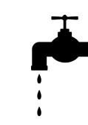
Why Americans Believe Things That Aren't
True e.g., global warming

July 23rd
The End of Water As We Know It

at the
College of Complexes weekly free speech forum
www.collegeofcomplexes.org
Dappers East Restaurant, 2901 W. Addison (free parking)
www.illinoisgreens.org

