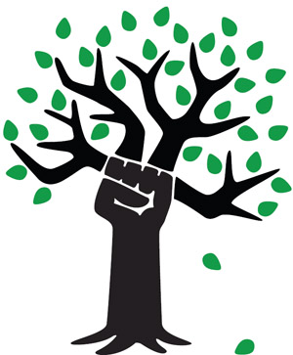
Chicago Greens
www.illinoisgreens.org

Special Upcoming Ecological Speakers
Each Program on Saturday at 6:00 PM

June 18th
COP 21: A Tale of Two Conferences
Int'l Environmental Conference of the Parties
Paris, France, a report

July 9th
Why Americans Believe Things That Aren't
True - e.g., global warming
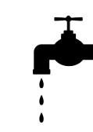
July 23rd
The End of Water As We Know It

at the
College of Complexes weekly free speech forum
www.collegeofcomplexes.org
Dappers East Restaurant, 2901 W. Addison (free parking)
www.illinoisgreens.org

